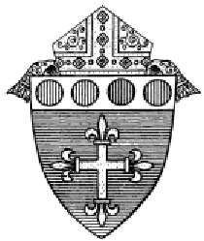
Diocese of Worcester

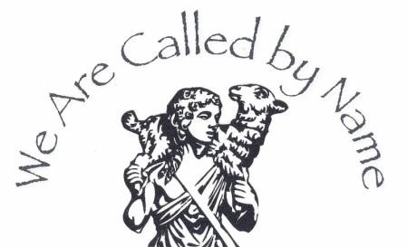
OFFICE OF RELIGIOUS EDUCATION
The Catechesis of the Good Shepherd Level I
Formation Course for Adults Part 2 Course 1-02692
Feb. 13, 14, 15, 2027 (Saturday, Sunday, Monday from 9-5 PM)
April 17, 18, 19, 2027 (Saturday, Sunday, Monday from 9-5 PM)

Our Lady of the Lake, 1400 Main Street, Leominster, MA 01453

Level 1 Catechesis of the Good Shepherd
Originated in 1954 by Sofia Cavalletti, a biblical scholar, and Gianna Gobbi, an educator of children and teachers, Level 1 Catechesis of the Good Shepherd helps the young child ages 3-6 (and their catechists) enter into a personal, intimate relationship with Jesus. It seeks to create a sacred space for children called the Atrium, in which both the children and their catechists can hear, ponder and celebrate the most essential mysteries of our Catholic faith as revealed in Scriptures and the Liturgy. This leads little children, and quite often their entire families to come to a deep appreciation for the sacraments and above all, the Eucharist.

Course Objectives
- To present the methodology and guiding principles of CGS for the 3-6 year old child
- To explore the religious nature and the most vital religious needs of the young child
- To meditate on the biblical and liturgical themes presented to children
- To offer guidelines and assistance for setting up an atrium, preparing an album and making materials
- To broaden the catechist’s ability to observe and learn from children, to listen with children to Scripture and to deepen the catechist’s enjoyment of God’s presence

Certification: The National Certificate of Completion will be issued upon the completion of Level I, Parts 1 and 2. The Level I certificate honors your full attendance and participation in the entire Level I course.

Formation Leader: Mary Pat Heelan has recently been named a Formation Leader for the Catechesis of the Good Shepherd. She studied Elementary Education at Boston College, worked for many years as a kindergarten teacher and has a Masters Degree in Pastoral Ministry from Anna Maria College. She is an Associate Director of Religious Ed for the Diocese of Worcester.
Tuition: The tuition for Level I Part 2 Formation for participants working in the Diocese of Worcester, MA will be $150 which includes a $35 fee for the National Association of Good Shepherd Certification. Tuition for those outside of the Diocese of Worcester, MA is $350. Catechists are also encouraged to become a member of CGS-USA prior to the beginning of the course. Please visit: https://www.cgsusa.org/connect/become-a-member/
Texts: We will use three texts for this course. Please let Mary Pat know if you need a book and she will order it for you. The Religious Potential of the Child 3rd edition, by Sofia Cavalletti, The Good Shepherd and the Child, The Joyful Journey by Cavalletti and others, and Nurturing the Whole Child by Gianna Gobbi.

Lunch, Snacks, Drinks: Please bring your own lunch, snacks and drinks with you each day.
Due Dates: Registration and Tuition is due on Feb. 1, 2027. Please register using this link:
https://worcesterdiocese.org/cgs-registration-level-1-part-1-winter-spring2026

For more information contact: Mary Pat Heelan mheelan@worcesterdiocese.org or call 508-929-4302.

